Movie Recommendation Generator User Manual

  - Husna Iqbal

Summary

The purpose of this app is to generate movie recommendations based upon various inputs from the user. This includes their current favorite movies, a genre they favor, minimum imbd rating of the movie, minimum and maximum release years of the movie, obscurity of the movie, number of recommendations wanted and the confidence of those recommendations. The app takes all these user inputs into consideration and generates a list of movie recommendations tailored to their liking.

User Inputs Reference Guide

What movies do you like?: Use this field to search for and select your favorite movies.

Enter Number of Recommendations: Configure the number of recommendations you would like to be generated based upon your inputs.

Confidence of Recommendations: This is used to set a minimum percentage of accuracy or confidence in the movie recommendations generated.

Max % of Users Who Have Rated the Movie: The user is able to set the maximum percentage a movie has been rated. This is from 0-30. The lower the percentage, the more obscure the movie.

Select a Genre: Choose a genre from the dropdown provided. The list of genres includes the following: Adventure, Animation, Children, Comedy, Fantasy, Romance, Drama, Action, Crime, Thriller, Horror, Mystery, Sci-Fi, IMAX, Documentary, War, Musical, Western, Film-Noir.

Select a Minimum Rating: The user is able to choose the minimum Imbd rating of the movies recommended.

Select Movies to Exclude: If there are certain movies the user has already seen but did not like, the user can identify these movies to ensure they are not included in the movies recommended.

Enter Minimum Year: This configures the minimum release year of movies.

Enter Maximum Year: This configures the maximum release year of movies.

Visual of User Inputs in Movie Recommendation Generator
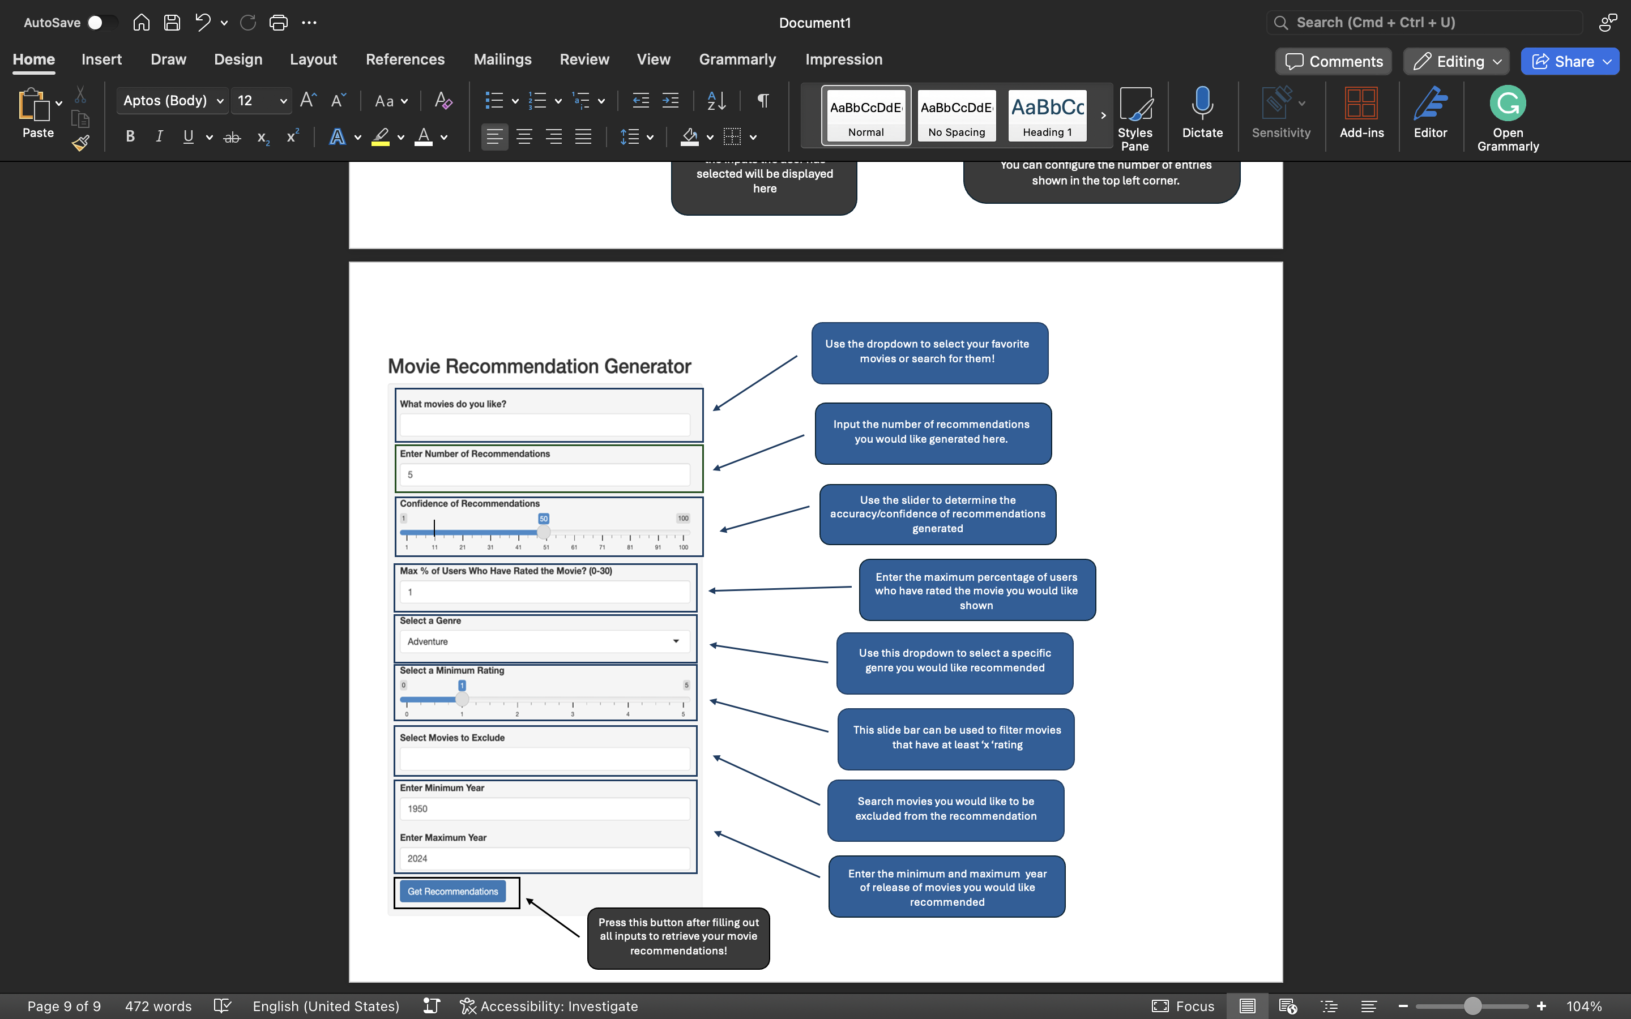

Visual of Output in Movie Recommendation Generator

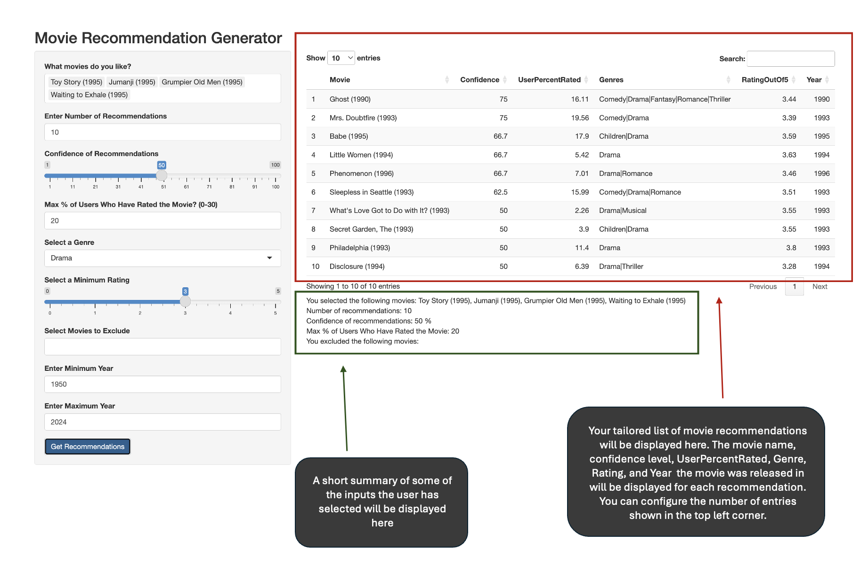

Graded Screenshot #1:

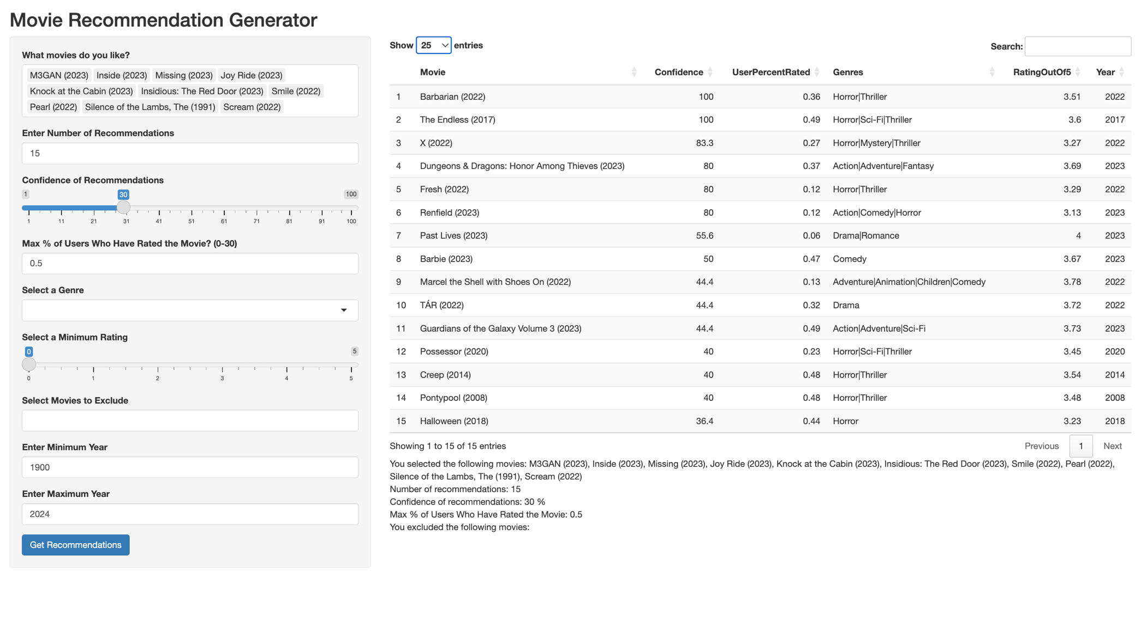
Graded Screenshot #2:

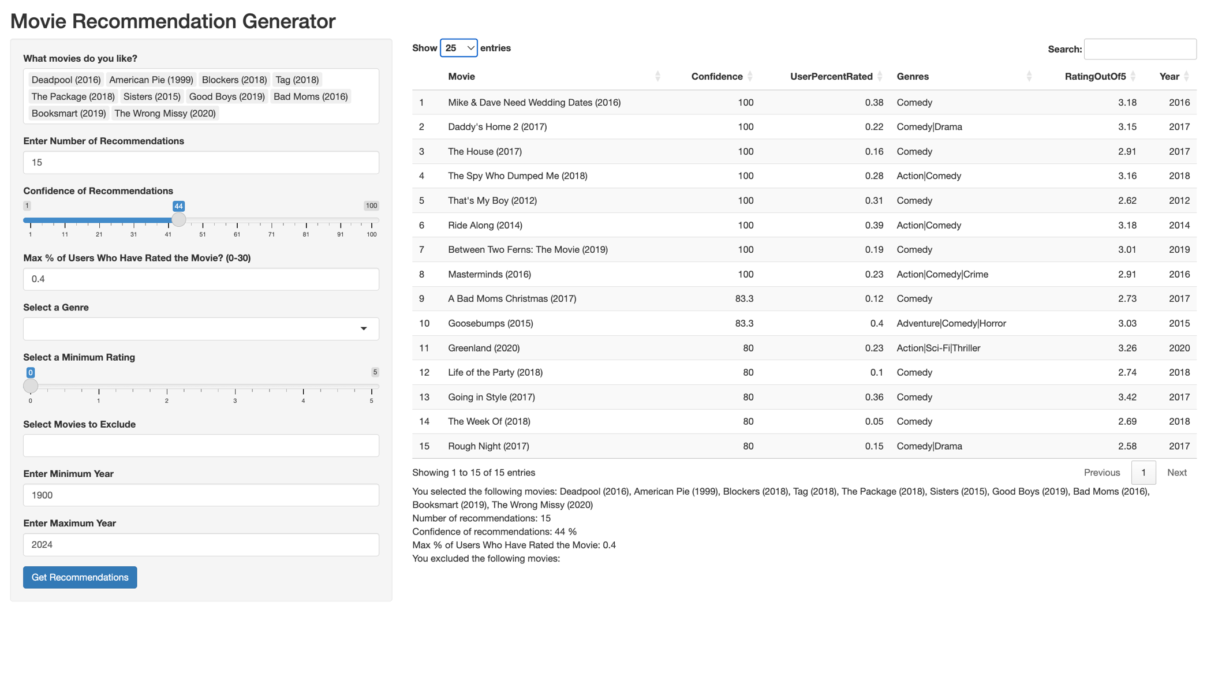
Graded Screenshot #3:

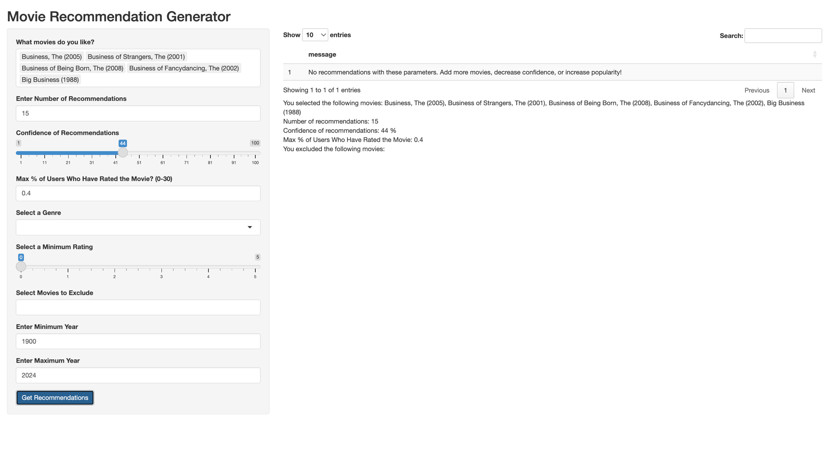
Graded Screenshot #4:

